PRACTICAL: 6

**AIM:** Implement Border Gateway protocol (BGP).

# THEORY:

* BGP stands for Border Gateway Protocol.
* BGP is a **standardized exterior gateway protocol designed to exchange routing and reachability information between autonomous systems (AS) on the Internet**.
* The protocol is often classified as a path vector protocol but is sometimes also classed as a distance-vector routing protocol*.*

# TOPOLOGY 1:

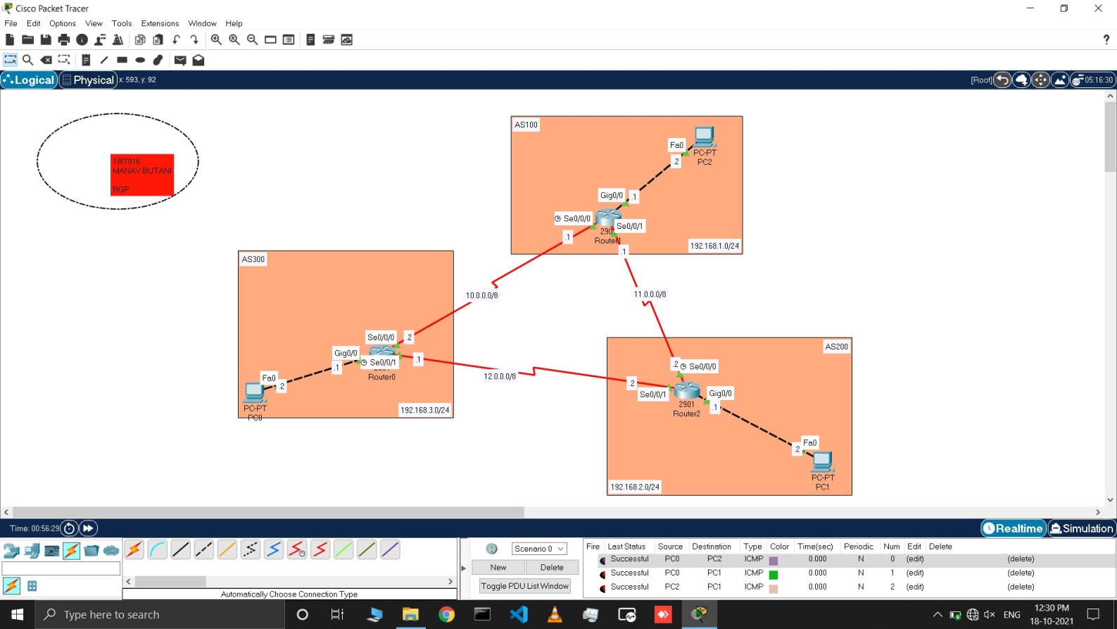

# Commands for Topology 1:

* First make the topology as shown in the above figure.
* Now open cli of router 0 and assign all IP address as shown in topology using cmd like
  + enable
  + configure terminal
  + interface <cable type> <cable port>
  + no shutdown

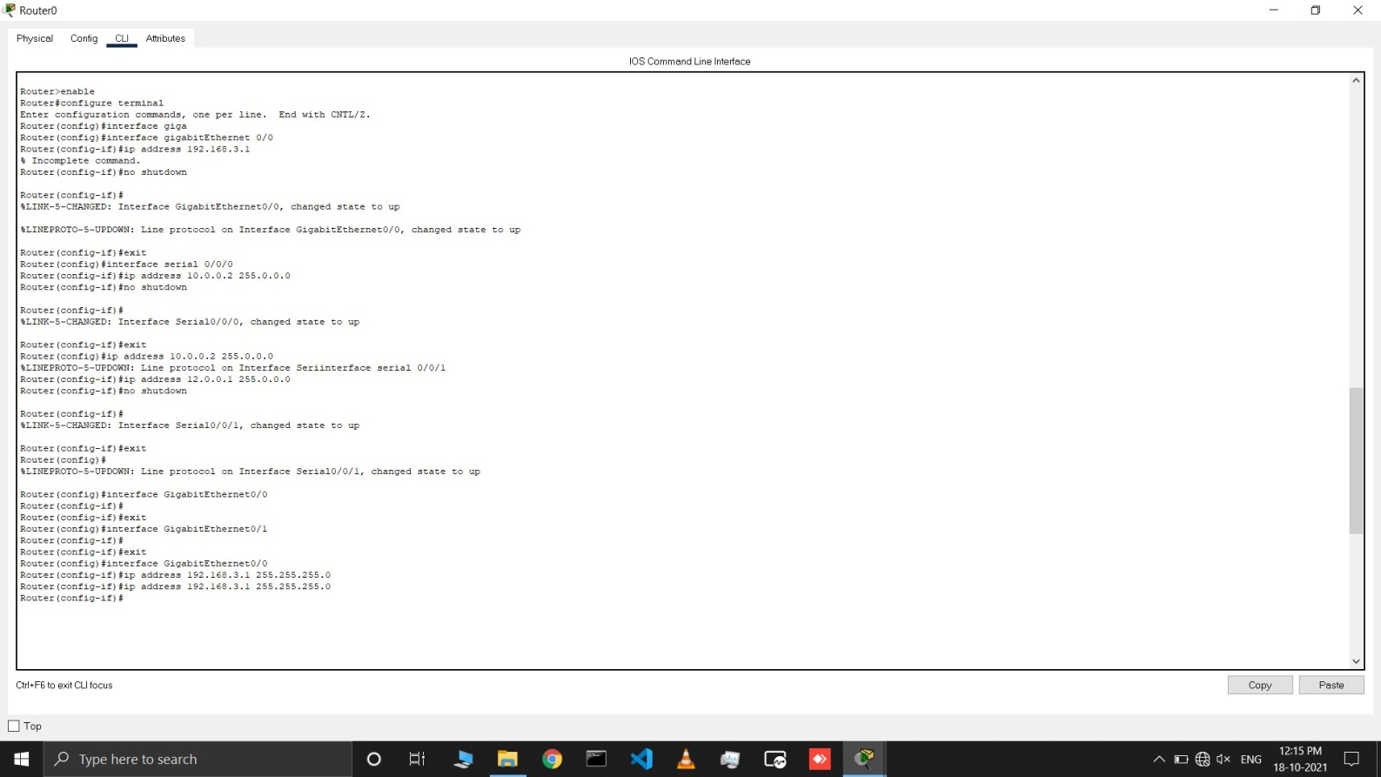

* Now add in BGP table using **router bgp <autonomous system no> ,** add neighbor with **neighbor <serial-id of connected router> remote-as <autonomous system no of next router area>** cmd and add each network with their network address using cmd **network <network address>** for all the network connected to router 0.

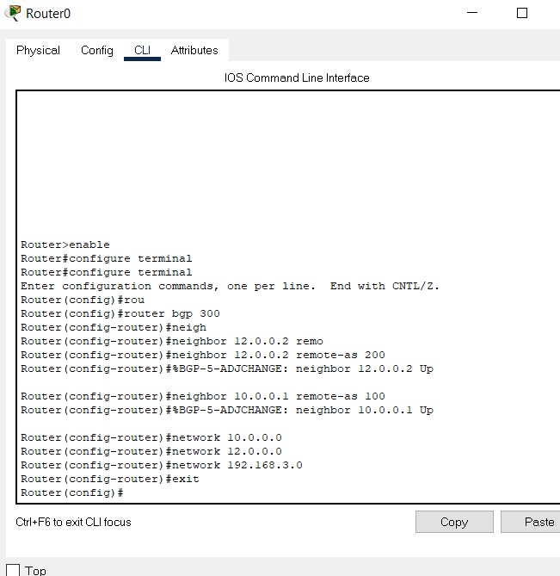

* Now open cli of router 2 and assign all IP address as shown in topology using cmd like
  + enable
  + configure terminal
  + interface <cable type> <cable port>
  + no shutdown

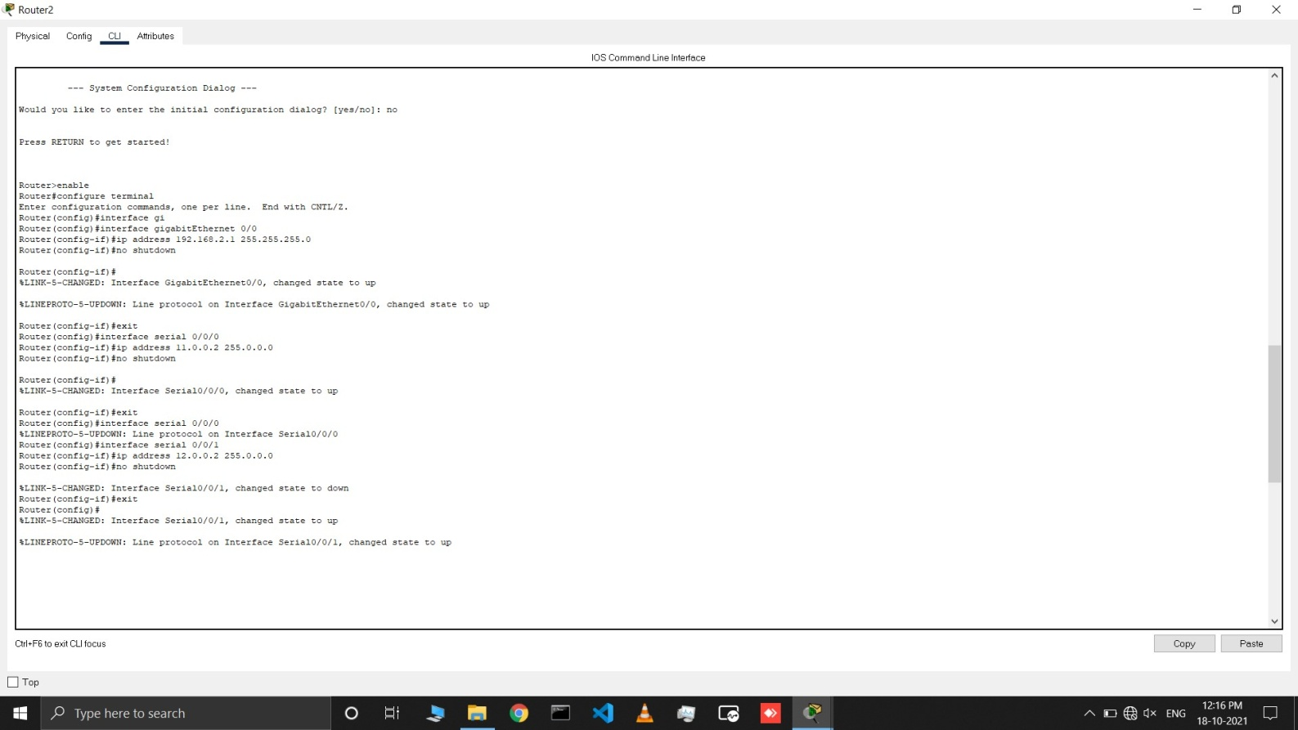

* Now add in BGP table using **router bgp <autonomous system no> ,** add neighbor with **neighbor <serial-id of connected router> remote-as <autonomous system no of next router area>** cmd and add each network with their network address using cmd **network <network address>** for all the network connected to router 2.

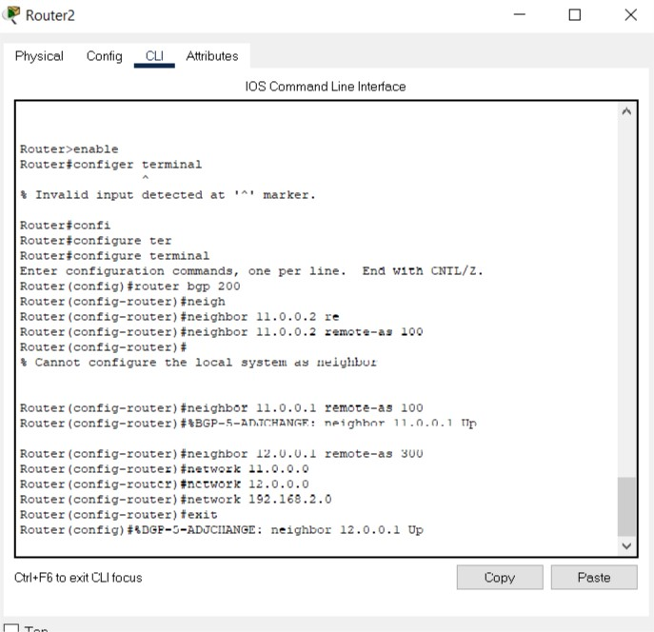

Repeat same procedure with router 1.

# OUTPUTS:

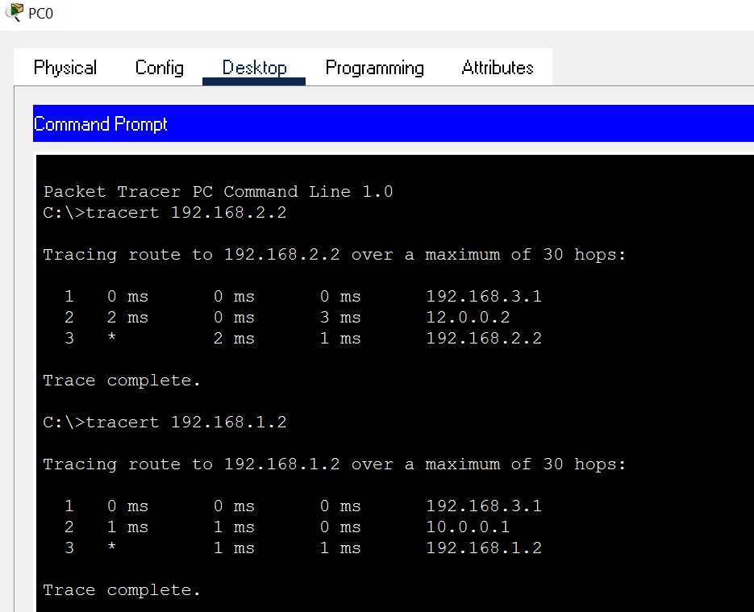

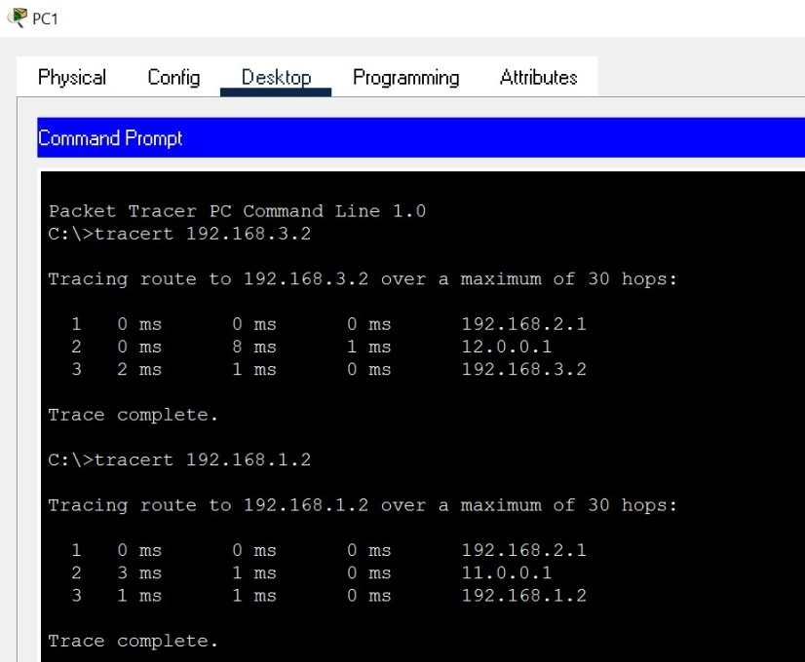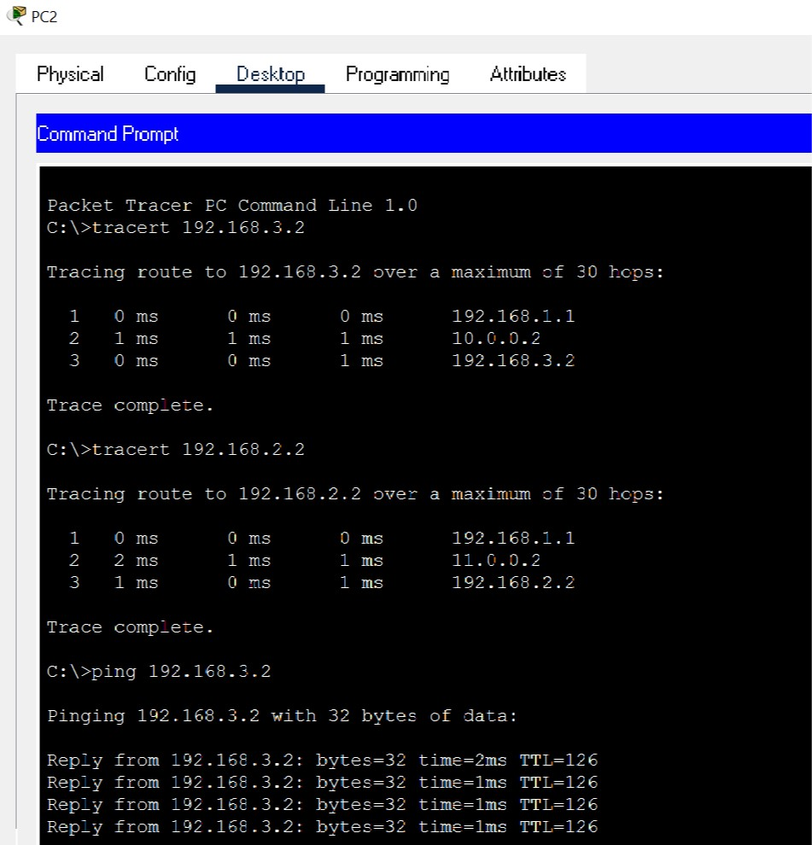

* Here we can see that we are able to transmit our packet to desired target in topology1.

# LATEST APPLICATIONS:

* Border Gateway Protocol (BGP) is the postal service of the Internet. When someone drops a letter into a mailbox, the Postal Service processes that piece of mail and chooses a fast, efficient route to deliver that letter to its recipient. Similarly, when someone submits data via the Internet, BGP is responsible for looking at all of the available paths that data could travel and picking the best route, which usually means hopping between autonomous systems.
* Runs Over TCP.
* BGP conserve network Bandwidth.
* BGP supports CIDR.
* BGP also supports Security.

# LEARNING OUTCOME:

* How to configure BGP routing in a network with classful and classless both class type.